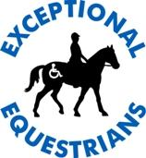
Exceptional Equestrians of the Missouri Valley, Inc.
785 Yellow Finch Lane Washington, MO 63090
Therapeutic Riding Program
2024 Participant Application
NAME: ___________________________________________________________________
STREET: _________________________________________________________________
CITY: __________________ COUNTY: ___________ STATE: _______ ZIP:___________
DIAGNOSIS: __________________________________ HOME PHONE: ______________
EMAIL ADDRESS: __________________________________________________________
BIRTH DATE: ___________ ETHNICITY: ____________ HEIGHT: ______ in. WEIGHT_______lbs.
GENDER: ______________ PREFERRED PRONOUN: HE/HIM, SHE/HER, THEY/THEM
If the participant is less than 18 years of age, the parent or legal guardian should fill in below:
Emergency Contact or
Parent _______________________ Phone #:________________Email:___________________
Employer ____________________ Address: _______________________________________
Parent _______________________ Phone #: ________________ Email:__________________
Employer ____________________ Address: _______________________________________

Name and Address of Legal Guardian (if different from participant or parent)
___________________________________________________ (phone) _______________
Name and Address of Caregiver (if different from participant or parent)
___________________________________________________ (phone) _________________
Participant receives service coordination from (please circle if applicable):
Compass Health Franklin Country SB40 Resource Board
Warren County Developmental Disabilities Board Gasconade County Board
Other: please specify_______________________
If Yes, Name of Service Coordinator __________________________________________
Not currently receiving service coordination, but am interested.
Please contact me with more information ____ (check line if applicable)

School Name/Occupation/Day program? ____________________________________
Please circle if the participant receives additional medical services
Physical Therapy Occupational Therapy Speech Therapy Mental Health services

If Yes, Name of Service Provider __________________________________________

Participant Profile

Participant has previously participated in equine assisted activities and therapies __Yes __No
If Yes, Please check all that apply: at EEMV____ at another center (specify)_____ how many years_____

Participant is (please circle): Ambulatory Non- ambulatory Verbal Non- verbal

Participant uses (circle): Wheelchair Crutches Braces Walker Cane
Speech-generating device (eg-Dynavox) PECS Cards Sign Language Other_________
Participant is able to sit independently: Yes No

How did you hear about Exceptional Equestrians?

EF Scanned

Exceptional Equestrians of the Missouri Valley, Inc.
785 Yellow Finch Lane, Washington, MO 63090
phone: 636-390-2141 fax: 636-900-9007

CONSENT FOR RELEASE OF INFORMATION:
I hereby authorize______________________________________________________(facility, individual, physician, etc.) to release information from the records of _____________________________(participant name) to Exceptional Equestrians of the Missouri Valley, Inc. for the purpose of developing a therapeutic riding program for the above-named participant. The information to be released is marked below. (Please make as many copies of this form as necessary for any additional releases needed.)

________Medical History

________Physical Therapy evaluation, assessment and program plan

________Occupational Therapy evaluation, assessment and program plan

________Speech Therapy evaluation, assessment and program plan

________Classroom Individual Education Plan (I. E. P.)

________Medical Insurance Provider, Please specify ______________________

________Other ____________________________________________________

Signature____________________________________________________________Date_______________

RESEARCH DATA RELEASE
The undersigned hereby grants permission to use all test results and scores obtained from evaluation, both formal and informal of above named rider while said rider was in attendance at programs associated with Exceptional Equestrians of the Missouri Valley, Inc. With regard to the foregoing statements, no use of the name of said individual will be included in published material. No promises have been made to me to secure my signature to this release other than the intention of Exceptional Equestrians of the Missouri Valley or associated programs or consultants to use the test results and scores obtained from evaluations for the purpose of educational work and research.
Signature____________________________________________________________Date_______________
PHOTO RELEASE
For valuable consideration given and which is hereby acknowledged, the undersigned hereby grants to Exceptional Equestrians of the Missouri Valley permission to take or have taken, still and moving photographs and films including television pictures of myself /son/ daughter /ward and / or pictures of parents /guardians / siblings and I consent and authorize Exceptional Equestrians of the Missouri Valley, Inc. its advertising agencies, news media and any other persons interested in Exceptional Equestrians of the Missouri Valley, Inc., PATH Int’l, AHA Inc. or other partners and supporters, and their work, to use and reproduce the photographs, films, and pictures to circulate and publicize the same by all means including without limitation the generality of the foregoing: newspapers, television media, brochures, pamphlets, instructional materials, books and clinical material.
With regard to the foregoing material, no inducements or promises have been made to me to secure my signature to this release other than the intention of Exceptional Equestrians of the Missouri Valley, Inc. to use or be used such photographs, films and pictures for the primary purpose of promoting and aiding Exceptional Equestrians of the Missouri Valley, Inc. and its work.
CONSENT: Signature______________________________________________________Date_______________

ONLY SIGN HERE IF YOU DO NOT CONSENT TO PHOTOGRAPHY:
NON-CONSENT SIGNATURE:_____________________________________Date_____________________________

Exceptional Equestrians of the Missouri Valley
785 Yellow Finch Lane, Washington, MO 63090
phone: 636-390-2141
fax: 636-239-7011

PARTICIPANT CONSENT, RELEASE AND INDEMNIFICATION AGREEMENT
I/we, the parent(s) / guardian(s)** of ______________________________________(participant’s name), do hereby consent to and assume the unavoidable risks inherent in all horse related activities of said rider’s participation in the therapeutic horsemanship program sponsored by Exceptional Equestrians the Missouri Valley Inc., located at 785 Yellow Finch, Washington, Missouri and / or other locations. I acknowledge and I understand that despite reasonable safety precautions, horsemanship experiences can result in injury and even death. I also acknowledge my understanding that there are no assurances that said rider will receive physical or psychological benefits from participation in said program and I understand that the ordinary risks associated with horseback riding are increased by virtue of said rider’s disability.
I understand that UNDER MISSOURI LAW AN EQUINE PROFESSIONAL IS NOT LIABLE FOR AN INJURY TO OR THE DEATH OF A PARTICIPANT IN EQUINE ACTIVITIES RESULTING FROM THE INHERENT RISKS OF EQUINE ACTIVITIES PURSUANT TO THE REVISED STATUTES OF MISSOURI. I also understand that, in the event of any accident which might occur, NO LIABILITY can be accepted by any organization concerned, including Exceptional Equestrians of the Missouri Valley, Inc., its agents or assigns. In consideration, therefore, for the privilege of riding, and / or working around horses at Exceptional Equestrians, the Undersigned does hereby agree to hold harmless and indemnify Exceptional Equestrians of the Missouri Valley, Inc., and further release them from any liability or responsibility for accident, damage, injury, or illness to the Undersigned or to any horse owned by the Undersigned, or to any family member or spectator accompanying the Undersigned on the premises.
For and in consideration of the agreement of Exceptional Equestrians of the Missouri Valley, Inc. to provide riding instructions to the aforesaid rider, I do hereby forever release, acquit, discharge and hold harmless Exceptional Equestrians of the Missouri Valley, Inc., their officers, directors, agents, employees, instructors, representatives and any therapists, volunteers and other persons associated with said program and the successors and assigns of each of them from all manner of claims, demands and damages of every kind and nature whatsoever which I or the aforesaid rider may now or in the future have against Exceptional Equestrians of the Missouri Valley, Inc., their officers, directors, agents, employees, instructors, representatives and any therapists, volunteers and other persons associated with said program and the successors and assigns of each of them on account of any personal injuries, physical or mental condition, known or unknown, to the person of the aforesaid rider, and the treatment thereof, as a result of, or in any way growing out of the acts or omissions of said parties in connection with said services or in any way incidental thereto.
Signature____________________________________________________________Date_______________

PHYSICIAN RELEASE AND INDEMNIFICATION AGREEMENT
I /We, the parent(s) / guardian(s)* of ____________________________________(name of participant), acknowledge that I understand the medical authorization of ___________________________________(name of physician) does not constitute any assurance that the above named rider will receive physical or psychological benefits from the program conducted by Exceptional Equestrians of the Missouri Valley, Inc., nor does it constitute an assessment of the risk of possible injury to said rider in relation to the possible physical or psychological benefits to said rider from participation in the program.

In consideration of the services and the medical authorization of aforesaid physician, I hereby waive, release and relinquish any and all claims against him/her for any and all liability arising from his/her authorization for said rider to participate in the program offered by Exceptional Equestrians of the Missouri Valley, Inc. and I hereby agree to hold harmless and indemnify said physician against any and all claims arising from said authorization. Signature____________________________________________________________Date_______________

Exceptional Equestrians of the Missouri Valley
785 Yellow Finch Lane, Washington, MO 63090
phone: 636-390-2141
fax: 636-239-7011

Please note that registration is limited and filing paperwork does not necessarily guarantee a place in the Exceptional Equestrians of the Missouri Valley, Inc. program schedule.
*In the event that you have sole legal custody of or are the sole living parent of the above named child /ward, only one signature is required, otherwise BOTH PARENTS OR GUARDIANS MUST SIGN prior to the child participating in the therapeutic riding program, Exceptional Equestrians of the Missouri Valley, Inc.

Your signature below indicates that you have read and understand all segments of this document.

Participant Signature ______________________________________________Date__________________

Mother / guardian Signature________________________________________________________Date__________________

Father / guardian Signature________________________________________________________Date_________________

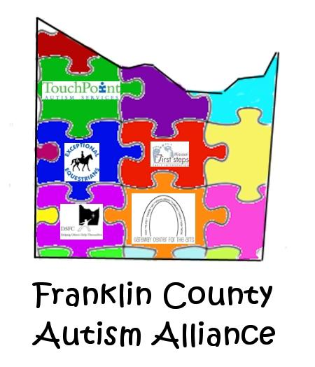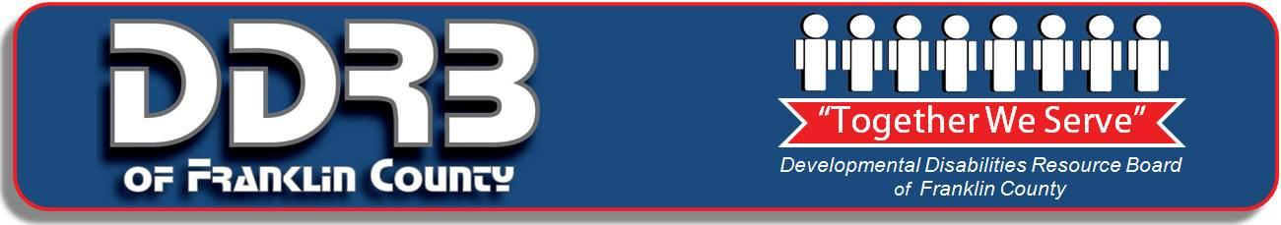

EEMV Policy of Eligibility for Program Participants
Valid for sessions held between 1/1/2024 and 12/31/2024
The following criteria will be considered for any riders being accepted into the program:
- Those wishing to participate in EEMV sessions will be evaluated to determine if their medical, physical, and/or psychosocial diagnosis is within the precautions and contraindications guidelines as defined by the PATH Medical Committee. These precautions and contraindications are intended to ensure the safety of the clients.
- Students are given a scheduled session time only if there is an adequate number of staff and volunteers to safely serve them, an appropriate available time slot, a horse deemed acceptable by EEMV staff, and appropriate tack.
- Students must have all required forms completed and turned into the office at least 2 weeks prior to participation in EEMV lessons or activities.
- All students’ weights will be reviewed at the beginning of each riding session prior to classes and more frequently if necessary. This is to ensure they are properly and safely paired with a horse that is within the rider’s weight range. Students will be served by EEMV as long as there is a horse/pony that is suitable for them to be partnered with. If there is not one available, the student will put in a ground work class, if suitable, or put on the current wait list and can return to riding when there is a suitable horse available.
- Students may be served by EEMV if their attitude and behavior is deemed appropriate by their instructor or therapist to ensure safety for the student, staff, horse and volunteers.
- Students must be current in their payments owed to EEMV prior to each session starting in order to participate in lessons. Participants must have paid their invoice prior to their first class.
- Participants in Therapeutic Riding must be ages 4 and up. Licensed Therapy participants must be ages 2 and up.
- The participant is willing to wear required safety equipment (closed toe shoes, helmet, weather appropriate clothing, long pants).
By Signing below, I agree to and understand these terms.

_______________________ ______________________
Parent or Rider if over 18 Date

________________________
Participant’s Printed Name

Exceptional Equestrians of the Missouri Valley, Inc.
785 Yellow Finch, Washington, MO 63090 Phone: (636) 390-2141 Fax: (636) 239-7011
Rider Medical History Form
*****MUST BE COMPLETED AND SIGNED BY PHYSICIAN!!!*****

Name of Rider: _________________________Date of Birth:____________Phone:___________
Address:______________________________________________________________________
Name of Parent/Guardian:________________________________________________________
Diagnosis: ________________________________________Date of Onset: ________________
*** For persons with Down’s Syndrome:
______ Negative Cervical X-ray for Atlanto-Axial Instability X-ray Date:______
______Negative for Clinical Symptoms of Atlanto-Axial Instability
** If Seizures
Seizure type: ___________________ Controlled?: ________Date of last seizure:_______
Tetanus shot: Date _________ (current tetanus required) Height________ Weight________
Medications:___________________________________________________________________________________________________________________________________________________________________________________
Please indicate if patient has a problem and/or surgeries in any of the following areas by checking yes or no. If yes, please comment.

Area | Yes | No | Comments
Allergies
Auditory
Visual
Cardiac
Circulatory
Pulmonary/Respiratory
Neurological
Muscular
Orthopedic
Learning Disability
Mental Impairment
Psychological Impairment
Other
Other
Other
Mobility: Independent Ambulation: Y ___ N___ Crutches: Y___ N___ Braces: Y___ N___ Wheelchair: Y___ N__

Precautions: ______________________________________
______________________________________
______________________________________
______________________________________
______________________________________
______________________________________
Physician Authorization
I hearby give medical authorization for the above named rider to participate in Exceptional Equestrians of Missouri Valley, Inc. Therapeutic riding program which includes an evaluation by a licensed therapist and a certified therapeutic riding instructor to assess functional levels and recommend riding exercises. To my knowledge there is no reason why this person cannot participate in supervised equestrian activities. However, I understand that the therapeutic riding center will weigh the medical information above against the existing precautions and contraindications. I concur with a review of this person’s abilities/limitations by a licensed/credentialed health professional (e.g. P.T., O. T., Speech Pathologist, Psychologist, etc.) in the implementing of an effective equestrian program. This authorization does not constitute any medical assurance that the person above named will receive physical or psychological benefits from the program conducted by Exceptional Equestrians of the Missouri Valley, Inc. Nor does it constitute an assessment of the risk of possible injury to said person in relation to the possible psychological or physical benefits from participation in the program.

Physician Name (please print) ___________________________________Phone:____________
Address: _____________________________________________________________________
Physician Signature: __________________________________ Date: ____________________

