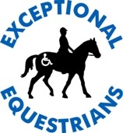
Exceptional Equestrians of the Missouri Valley, Inc.

Yellow Finch Lane
Washington, MO 63090
Therapeutic Riding Program
2017 Participant Application
NAME: ___________________________________________________________________ STREET: _________________________________________________________________
CITY: __________________ COUNTY: ___________ STATE: _______ ZIP:___________ DIAGNOSIS: __________________________________ HOME PHONE: _______________ BIRTH DATE: ______________ GENDER: _____ HEIGHT: ______ in. WEIGHT_______lbs.
EMAIL ADDRESS: ____________________________________________________________

If the participant is less than 18 years of age, the parent or legal guardian should fill in below:
Parent _______________________ Phone #:________________ Alt. #:___________________
Employer ____________________ Address: _______________________________________ Parent _______________________ Phone #: ________________ Alt. #:__________________
Employer ____________________ Address: ________________________________________

Name and Address of Legal Guardian (if different from participant or parent)
___________________________________________________ (phone) _______________ Name and Address of Caregiver (if different from participant or parent)
___________________________________________________ (phone) _________________

Participant receives service coordination from (please circle if applicable):

Developmental Services of Franklin County Warren County Developmental Disabilities Board Other: please specify__________________________________

If Yes, Name of Service Coordinator ________________________________________________ Not currently receiving service coordination, but am interested. Please contact me with more
information ____ (check line if applicable)

Participant Profile
Participant has previously participated in equine assisted activities and therapies __Yes __No If Yes, Please check all that apply:
at EEMV____ at another center (specify)_____ how many years_____

Participant is (please circle): Ambulatory Non- ambulatory Verbal Non- verbal

Participant uses (circle): Wheelchair Crutches Braces Walker Cane Speech-generating device (eg-Dynavox) PECS Cards Sign Language Other_________

Participant is able to sit independently: Yes No

What are you looking to accomplish from Therapeutic Riding?
_________________________________________________________________________________ _________________________________________________________________________________

1
Exceptional Equestrians of the Missouri Valley, Inc.
785 Yellow Finch Lane, Washington, MO 63090 phone: 636-390-2141
fax: 636-239-7011

CONSENT FOR RELEASE OF INFORMATION:
I hereby authorize______________________________________________________(facility, individual, physician, etc.) to release information from the records of _____________________________(participant name) to Exceptional Equestrians of the Missouri Valley, Inc. for the purpose of developing a therapeutic riding program for the above-named participant. The information to be released is marked below. (Please make as many copies of this form as necessary for any additional releases needed.)

________Medical History

________Physical Therapy evaluation, assessment and program plan

________Occupational Therapy evaluation, assessment and program plan

________Speech Therapy evaluation, assessment and program plan

________Classroom Individual Education Plan (I. E. P.)

________Other____________________________________________________________

Signature____________________________________________________________Date_______________

RESEARCH DATA RELEASE
The undersigned hereby grants permission to use all test results and scores obtained from evaluation, both formal and informal of above named rider while said rider was in attendance at programs associated with Exceptional Equestrians of the Missouri Valley, Inc.
With regard to the foregoing statements, no use of the name of said individual will be included in published material. No promises have been made to me to secure my signature to this release other than the intention of Exceptional
Equestrians of the Missouri Valley or associated programs or consultants to use the test results and scores obtained from evaluations for the purpose of educational work and research. **Initials______

PHOTO RELEASE
For valuable consideration given and which is hereby acknowledged, the undersigned hereby grants to Exceptional Equestrians of the Missouri Valley permission to take or have taken, still and moving photographs and films including television pictures of myself /son/ daughter /ward and / or pictures of parents /guardians / siblings and I consent and authorize Exceptional Equestrians of the Missouri Valley, Inc. its advertising agencies, news media and any other persons interested in Exceptional Equestrians of the Missouri Valley, Inc., PATH Int’l, AHA Inc. or other partners and supporters, and their work, to use and reproduce the photographs, films, and pictures to circulate and publicize the same by all means including without limitation the generality of the foregoing: newspapers, television media, brochures, pamphlets, instructional materials, books and clinical material.
With regard to the foregoing material, no inducements or promises have been made to me to secure my signature to this release other than the intention of Exceptional Equestrians of the Missouri Valley, Inc. to use or be used such photographs, films and pictures for the primary purpose of promoting and aiding Exceptional Equestrians of the Missouri Valley, Inc. and its work.
CONSENT **Initials________
NON- CONSENT **Initials________
2

Exceptional Equestrians of the Missouri Valley
785
Yellow Finch Lane, Washington, MO 63090
phone: 636-390-2141
fax: 636-239-7011

PARTICIPANT CONSENT, RELEASE AND INDEMNIFICATION AGREEMENT
I/we, the parent(s) / guardian(s)** of ______________________________________(participant’s name), do hereby consent to and assume the unavoidable risks inherent in all horse related activities of said rider’s participation in the therapeutic horsemanship program sponsored by Exceptional Equestrians the Missouri Valley Inc., located at 785 Yellow Finch, Washington, Missouri and / or other locations. I acknowledge and I understand that despite reasonable safety precautions, horsemanship experiences can result in injury and even death. I also acknowledge my understanding that there are no assurances that said rider will receive physical or psychological benefits from participation in said program and I understand that the ordinary risks associated with horseback riding are increased by virtue of said rider’s disability.
I understand that UNDER MISSOURI LAW AN EQUINE PROFESSIONAL IS NOT LIABLE FOR AN INJURY TO OR
THE DEATH OF A PARTICIPANT IN EQUINE ACTIVITIES RESULTING FROM THE INHERENT RISKS OF EQUINE ACTIVITIES PURSUANT TO THE REVISED STATUTES OF MISSOURI. I also understand that, in the event of any accident which might occur, NO LIABILITY can be accepted by any organization concerned, including Exceptional Equestrians of the Missouri Valley, Inc., its agents or assigns. In consideration, therefore, for the privilege of riding, and / or working around horses at Exceptional Equestrians, the Undersigned does hereby agree to hold harmless and indemnify Exceptional Equestrians of the Missouri Valley, Inc., and further release them from any liability or responsibility for accident, damage, injury, or illness to the Undersigned or to any horse owned by the Undersigned, or to any family member or spectator accompanying the Undersigned on the premises.
For and in consideration of the agreement of Exceptional Equestrians of the Missouri Valley, Inc. to provide riding instructions to the aforesaid rider, I do hereby forever release, acquit, discharge and hold harmless Exceptional
Equestrians of the Missouri Valley, Inc., their officers, directors, agents, employees, instructors, representatives and any therapists, volunteers and other persons associated with said program and the successors and assigns of each of them from all manner of claims, demands and damages of every kind and nature whatsoever which I or the aforesaid rider may now or in the future have against Exceptional Equestrians of the Missouri Valley, Inc., their officers, directors, agents, employees, instructors, representatives and any therapists, volunteers and other persons associated with said program and the successors and assigns of each of them on account of any personal injuries, physical or mental condition, known or unknown, to the person of the aforesaid rider, and the treatment thereof, as a result of, or in any way growing out of the acts or omissions of said parties in connection with said services or in any way incidental thereto. **Initials________

PHYSICIAN RELEASE AND INDEMNIFICATION AGREEMENT
I /We, the parent(s) / guardian(s)* of ____________________________________(name of participant), acknowledge that I understand the medical authorization of ___________________________________(name of physician) does not constitute any assurance that the above named rider will receive physical or psychological benefits from the program conducted by Exceptional Equestrians of the Missouri Valley, Inc., nor does it constitute an assessment of the risk of possible injury to said rider in relation to the possible physical or psychological benefits to said rider from participation in the program.

In consideration of the services and the medical authorization of aforesaid physician, I hereby waive, release and relinquish any and all claims against him/her for any and all liability arising from his/her authorization for said rider to participate in the program offered by Exceptional Equestrians of the Missouri Valley, Inc. and I hereby agree to hold harmless and indemnify said physician against any and all claims arising from said authorization.
**Initials__________

Exceptional Equestrians of the Missouri Valley
785 Yellow Finch Lane, Washington, MO 63090 phone: 636-390-2141
fax: 636-239-7011

Please note that registration is limited and filing paperwork does not necessarily guarantee a place in the Exceptional Equestrians of the Missouri Valley, Inc. program schedule.
*In the event that you have sole legal custody of or are the sole living parent of the above named child /ward, only one signature is required, otherwise BOTH PARENTS OR GUARDIANS MUST SIGN prior to the child participating in the therapeutic riding program, Exceptional Equestrians of the Missouri Valley, Inc.

Your signature below indicates that you have read and understand and give consent to all segments of this document.

Participant Signature ______________________________________________Date__________________

Mother / guardian
Signature________________________________________________________Date__________________

Father / guardian
Signature________________________________________________________Date_________________

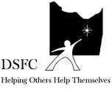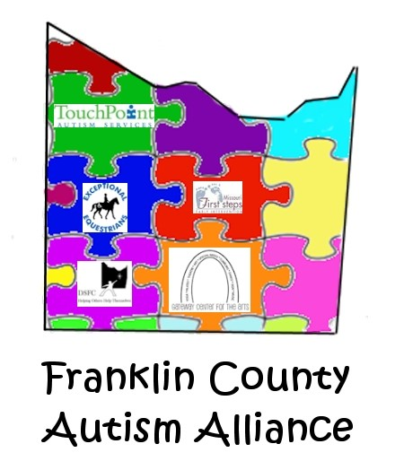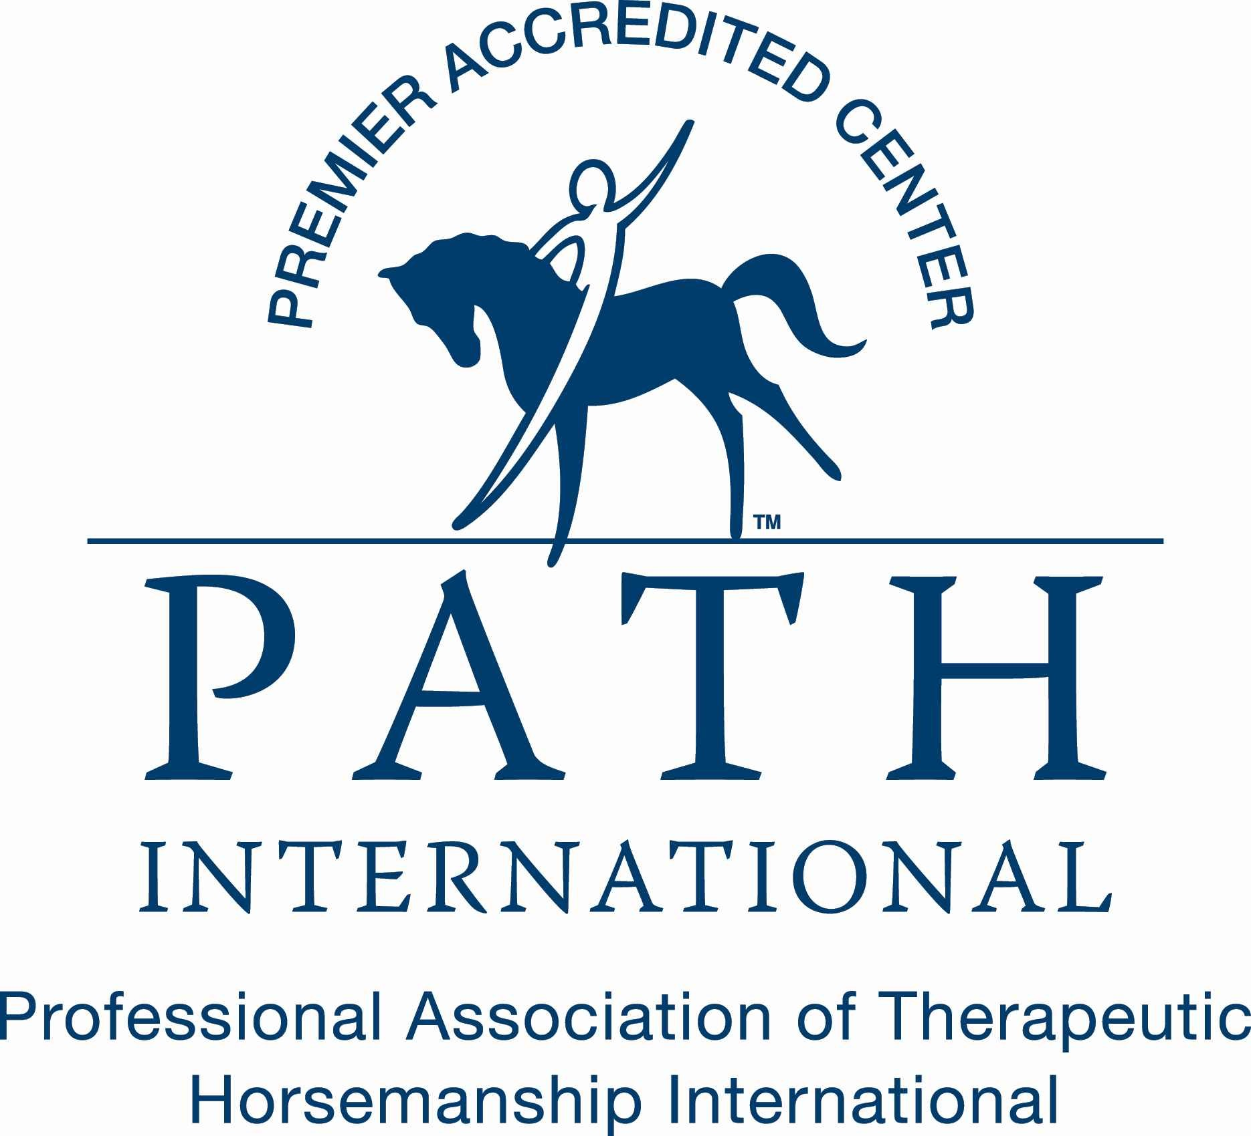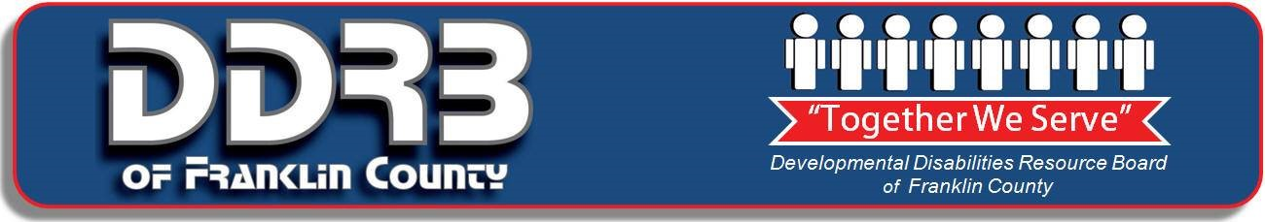

Exceptional Equestrians of the Missouri Valley, Inc.
785 Yellow Finch Lane, Washington, MO 63090 Phone: (636) 390-2141 Fax: (636) 239-7011
Participant Medical History Form
*****MUST BE COMPLETED AND SIGNED BY PHYSICIAN!!!*****

Name of Participant: _________________________Date of Birth:____________Phone:___________
Address:______________________________________________________________________
Name of Parent/Guardian:________________________________________________________ Diagnosis: ________________________________________Date of Onset: ________________
** If Seizures
Seizure type: ___________________ Controlled?: ________Date of last seizure:_______
Tetanus shot: Date _________ (current tetanus required) Height________ Weight________
Medications:___________________________________________________________________

Please indicate if patient has a problem and/or surgeries in any of the following areas by checking yes.

Area | Yes | Comments
Allergies
Auditory
Visual
Cardiac/Pulmonary/
Respiratory
Circulatory
Neurological
Muscular
Orthopedic
Psychological Impairment
Other
Mobility: Independent Ambulation: Y ___ N___
Crutches: Y___ N___ Braces: Y___ N___
Wheelchair: Y___ N___

Precautions:
_________________________________________
_________________________________________
_________________________________________ _________________________________________ _________________________________________

Physician Authorization
I hereby give medical authorization for the above named individual to participate in
Exceptional Equestrians of Missouri Valley, Inc.
equine assisted activity and therapy (EAAT) center which includes an evaluation by a certified therapeutic riding instructor and/or Missouri state licensed therapist to assess functional levels and recommend exercises. To my knowledge there is no reason why this person cannot participate in supervised equestrian activities and therapy activities. However, I understand that Exceptional Equestrians will weigh the medical information above against the existing precautions and contraindications. I concur with a review of this person’s abilities/limitations by a licensed/credentialed EAAT professional in the implementing of an effective EAAT program. This authorization does not constitute any medical assurance that the person above named will receive physical or psychological benefits from the program conducted by Exceptional Equestrians of the Missouri Valley, Inc. Nor does it constitute an assessment of the risk of possible injury to said person in relation to the possible psychological or physical benefits from participation in the program.
Physician Name (please print) ___________________________________Phone:____________
Address: _____________________________________________________________________
Physician Signature: __________________________________ Date: ____________________

